DOWNLOAD
AND
INSTALLATION OF MICROSOFT OFFICE/EXCEL 365
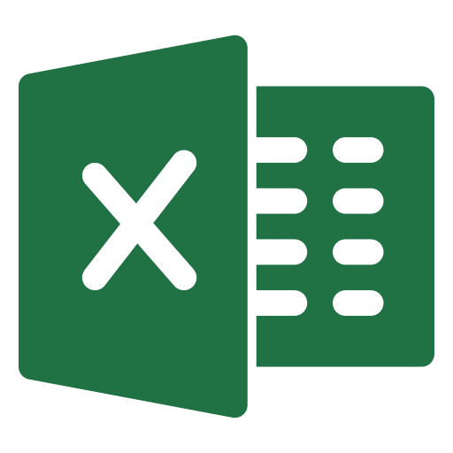

Steps to Download Microsoft Office/Excel 365
Microsoft Office is a software that embodies some other applications including Microsoft excel.
Here we are going walking through the following steps required to download Microsoft excel 365 (latest Edition);

Step 1: Click on the link below to take you to Microsoft office 365.
https://www.office.com/

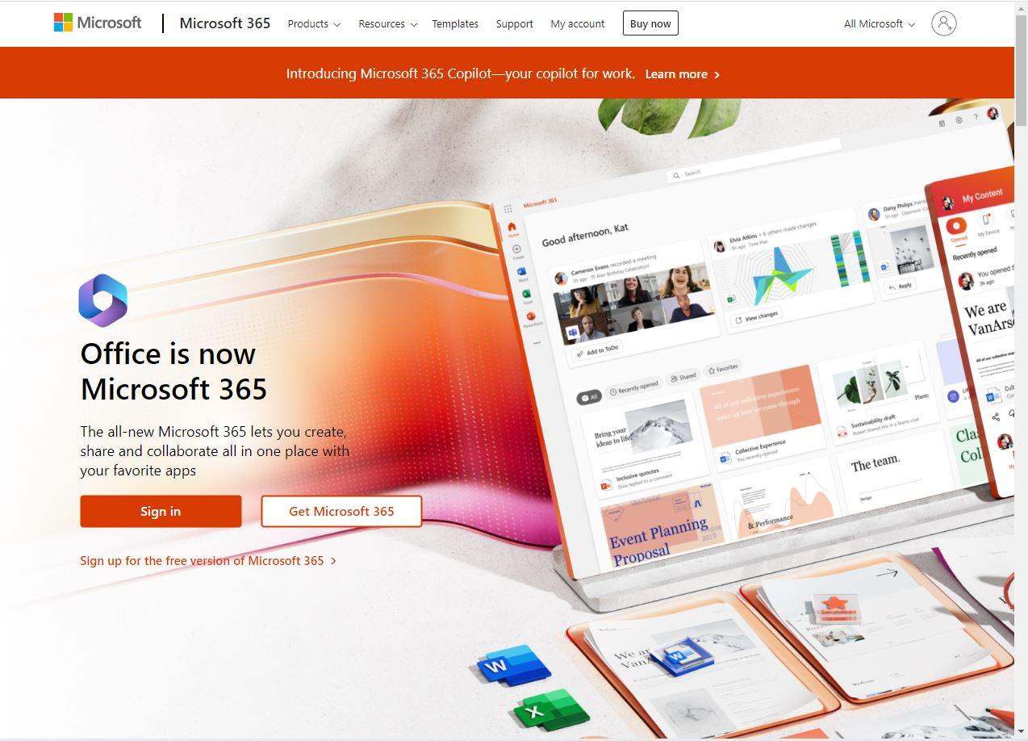

Step 2: To create a new account on Office 365, click on Sign from step 1 or, alternatively, click HERE and “create one”.
Then, follow the required steps for opening a Microsoft account.
You can use a Gmail, Hotmail, Yahoo Mail, etc. account to create an account on the link and enter your convenient password.

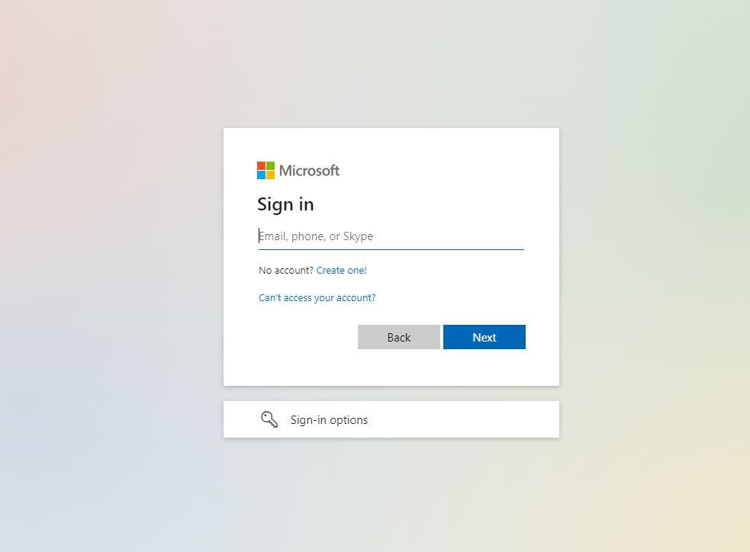

Once you have signed in, you’ll need to go back to your mailbox and activate or confirm the registration on Microsoft Office.
Having confirmed with an activation link sent into your mail, Sign in again with your registered mail into Microsoft Office from step 2 but this time around enter your email and password to sign in.

Step 3: You have a sample screenshot below of what you’ll likely see, go to the top right of the page where you have your initials.
Click on the initials, and you’ll have a drop dialog box.
Click on My Microsoft Account.

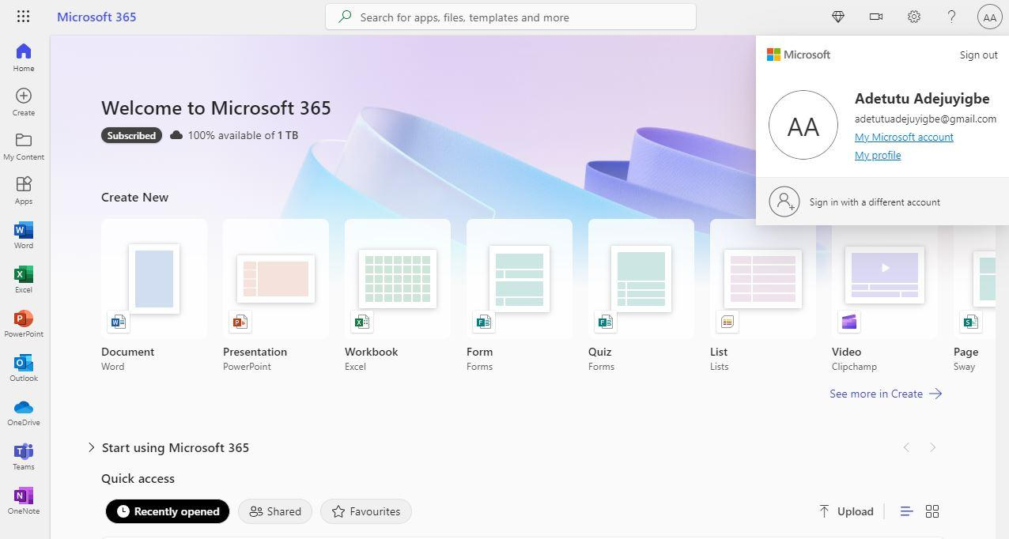

Step 4: You navigate on that page to “Service and Subscription,” then check through the subscription with its different features and make your preferred choice of monthly plan for Microsoft 365.
There are two types of subscription plan;
- Personal (1 person) and family (6 people) plans per month.
- Personal (1 person) and family (6 people) plans per year.

Having chosen you desired plan, you can click on buy and follow the payment method process, i.e., card details, Paypal etc

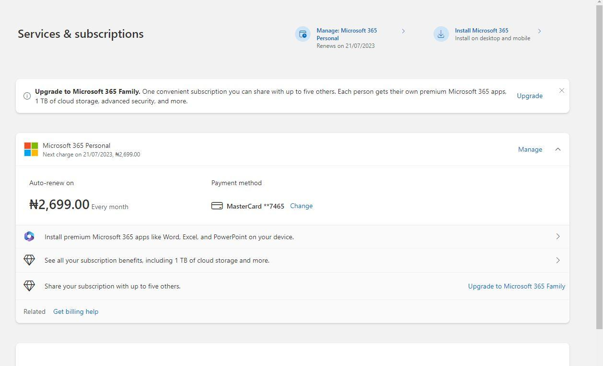

Here is a sample of a Microsoft 365 subscription where you can monitor, manage, and renew your subscription.

Step 5: Alternatively, you can click on this link for more information on the features of the different plans for subscription to Microsoft 365.

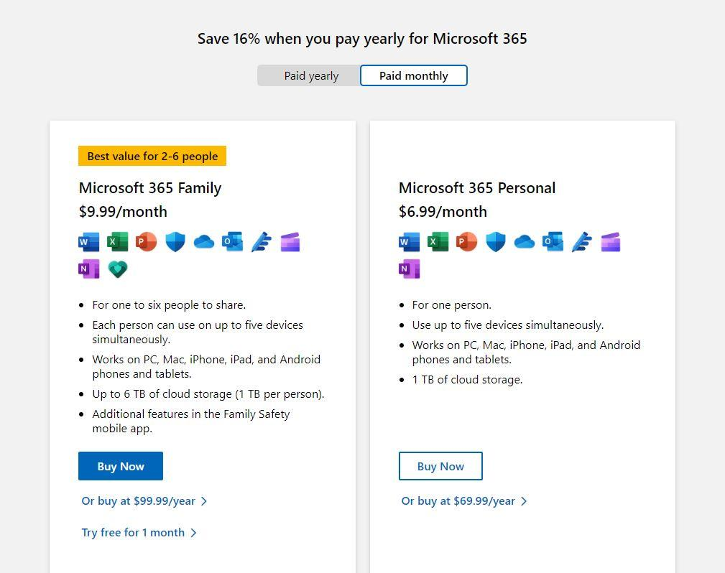

Step 6: Click on the dots at the top right of the page and then go to Excel.

Click on the Excel app to download /launch on your computer/Laptop which you can use anytime offline.

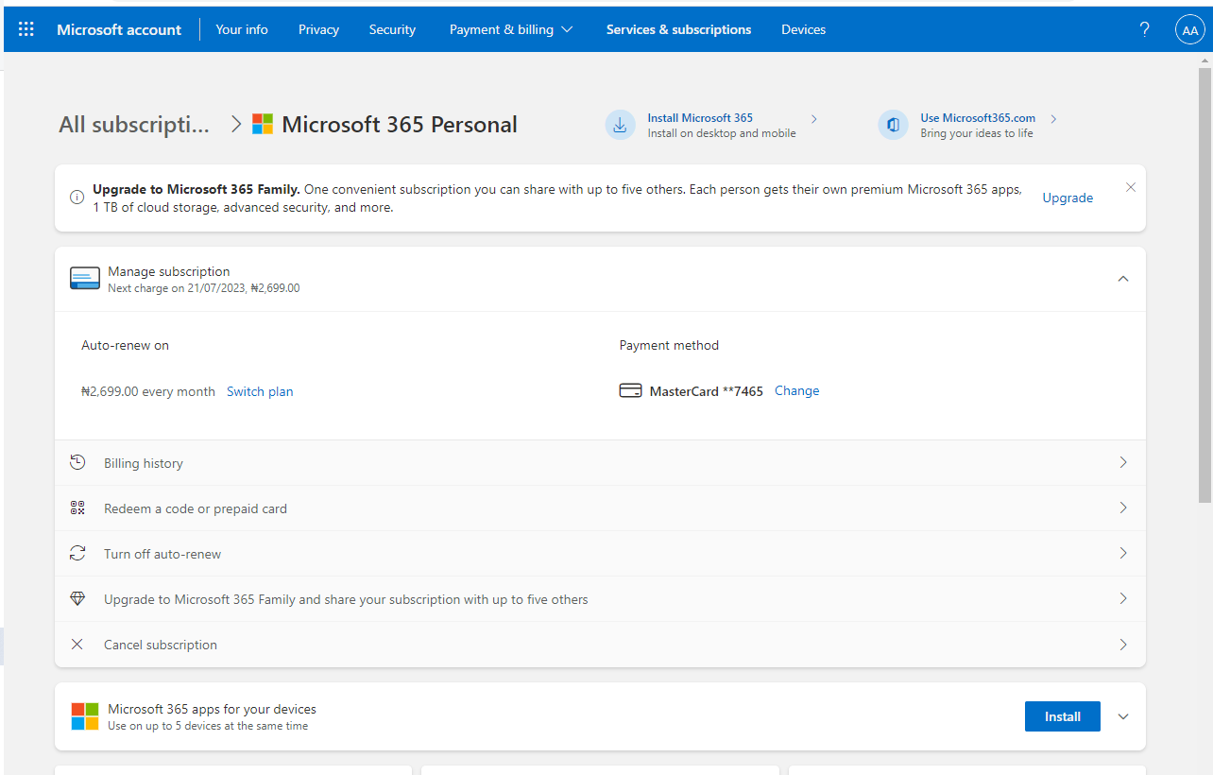

To unsubscribe on the payment plan of microsoft 365;
Here are the steps;
- Clicking on Manage beside Microsoft 365 Personal or Family under the Services and Subscription tab.
- Then Click on Switch Plan to stop auto renew and Excel can still do its job.

The difference between the subscribed plan and the unsubscribed plan is the 1 TB of cloud storage you get when your subscription is still valid. Every other feature is still available for use once you’ve completed your first subscription plan.

